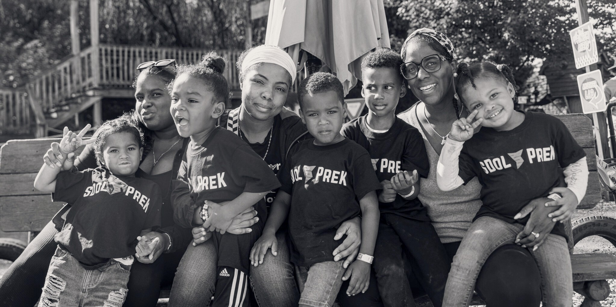



DONATIONS SERVE OUR COMMUNITY
SUPPORT FAMILIES IN TRANSITION

FIT #60003

Donation Center Hours
Monday - Saturday: 9am-6pm

Thrift Store Hours

Monday - Saturday: 9am-9pm
Donated items in FIT’s name supports students and families to be able to shop at Community Aid, and all you have to do is give them the membership number when they donate

Accepted Donations

Shoes Electronics Clothing Housewares Toys/Games & more!

For full donation guide, scan QR code or visit Community Aid website


DONATION CENTERS AT ALL STORES
DONATION BINS
IN OUR COMMUNITY

